**Projector Screen**

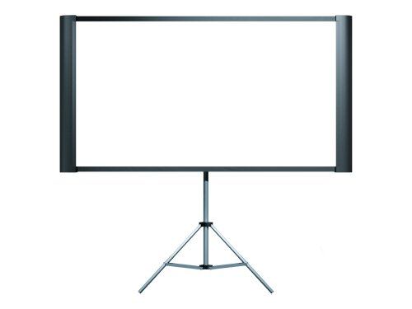

**Specifications:**

|  |  |
| --- | --- |
| Style | Duet |
| Front/Rear Projection | Front |
| Mount | Floor standing or wall mountable |
| Finish | Matte White |
| Tension Control | Permanently tensioned |
| Overall Size | * In video format: 42.5 x 61.75" (1 x 1.6m) * In HDTV format: 42.5 x 79.5" (1 x 2m) * Without the stand the height is 42.5" and with the stand it's 76.25"; When closed, the screen is 9" wide |
| Image Size | * In video format: 42.5 x 61.75" (1 x 1.6m) * In HDTV format: 42.5 x 79.5" (1 x 2m) |
| Diagonal | * Video format: 75" (1.9m) * HDTV format: 80" (2.0m) (Approx) |
| Format | Video and HDTV |
| Aspect Ratio | 4:3 and 16:9 |
| Color | Black frame |
| Length | 43" (1.1m) |

**DC-21 Document Camera Epson**

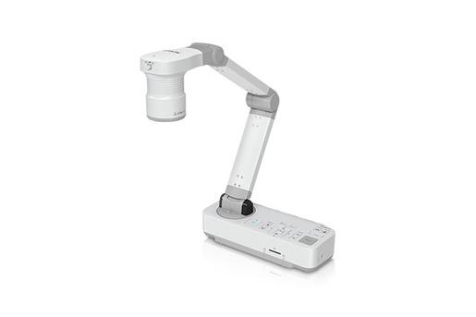

**Specifications:**

|  |  |
| --- | --- |
| **Input Terminal** | * HDMI * Computer In (VGA) * Display Out (VGA) * USB-B (for connection to PC/Mac®) * SD Card Slot |
| **Driver** | * TWAIN (for Windows) |
| **Functions** | * Rotation, Zoom (+, -, selectable, x1) * Auto Focus * Freeze, Record * Time-lapse * Picture Control (Brightness, Contrast, White Balance, Auto White Balance) |
| **Saving Format** | * Still Image: JPG, BMP, PNG * Video (Windows): AVI * Video (Mac): MOV * Other: PDF, EIT |
| **Operating Systems** | * Windows 7 * Windows 8 * Windows 10 * Windows Vista * Mac OS X 10.7.x, 10.8.x, 10.9.x, 10.10.x, 10.11.x |
| **Temperature** | * 41 ° to 95 °F (5 ° to 35 °C) |
| **Weight** | * 5.8 lb |
| **Power Supply Voltage** | * 100 - 240 V AC |
| **Rated Frequency** | * 50/60 Hz |
| **Power Consumption** | * 13 W (Operating) * 0.5 W (Standby Mode) |
| **Output Voltage of AC Power Adapter:** | * DC 12 V |

**Powerlite 1795F Wireless full HD 1080 3lcd projector epson**

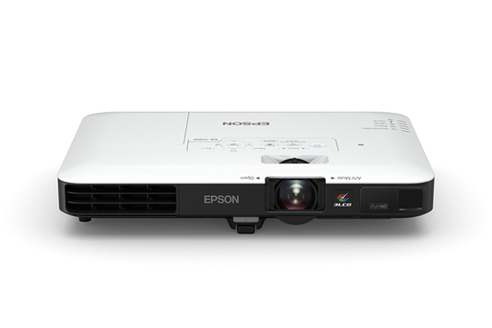

**Specifications:**

|  |  |
| --- | --- |
| **Projection Method** | * Front/rear ceiling mount * Front/rear desktop |
| **Pixel Number** | * 2,073,600 dots (1920 x 1080) x 3 |
| **Aspect Ratio** | * 16:9 |
| **Native Resolution** | * 1920 x 1080 (1080p) |
| **Resize** | * 640 x 480 (VGA) * 800 x 600 (SVGA) * 1024 x 768 (XGA) * 1280 x 800 (WXGA) * 1280 x 1024 (SXGA) * 1400 x 1050 (SXGA+) * 1440 x 900 (WXGA+) * 1680 x 1050 (WSXGA+) * 1600 x 1200 (UXGA) * 1920 x 1200 (WUXGA) |
| **Lamp Life** | * 7,000 hours (ECO Mode) * 4,000 hours (Normal Mode |
| **Size - projected distance** | * 30" to 300" (2.2 to 27.2 ft) |
| **Keystone Correction** | * Automatic Vertical: ± 30 degrees |
| **Automatic Horizontal** | * ± 20 degrees |
| **Contrast Ratio** | * Up to 10,000:1 |
| **Color Reproduction** | * Up to 1.07 billion colors |
| **Weight** | * 4.0 lb |
| **Operating Temperature** | * 41 ° to 95 °F (5 ° to 35 °C) |
| **Type** | * Optical Zoom (Manual) * Focus (Powered) |
| **Focal Length** | * 14.06 – 16.82 mm |
| **Zoom Ratio** | * Optical zoom 1.0 – 1.2 |
| **Display Performance** | * NTSC: 480 line * PAL: 576 line |
| **Input Signal** | * NTSC * NTSC4.43 * PAL * M-PAL * N-PAL * PAL60 * SECAM SDTV * HDTV |
| **Interfaces** | * 1x HDMI (Supports MHL® connectivity) * Computer/component video: 1x D-sub 15 pin * Composite video: 1x RCA * USB Type A: 1x PC-free USB and other * USB Type B: 1x USB Plug ‘n Play |
| **Audio Output** | * 1 W mono speaker |
| **Operating Distance** | * 19.7 ft |
| **Operating Angle** | * Right/left: Front: ± 60 degrees; rear: ± 30 degrees * Upper/lower: Front: ± 30 degrees; rear: ± 30 degrees |
| **Power Supply Voltage** | * 100 – 240 V ±10%, 50/60 Hz |
| **Power Consumption** | * 309 W (Normal Mode), 217 W (ECO Mode) |
| **Features** | * Power * Source Search Selection * Computer * Video * A/V Mute * Freeze * User ID * Auto * Aspect * Color Mode * NUM * Page Up and Down * E-zoom * Volume * Help * Menu * Enter * ESC and Pointer functions |

**EX3240 SVGA 3lCD projector epson**

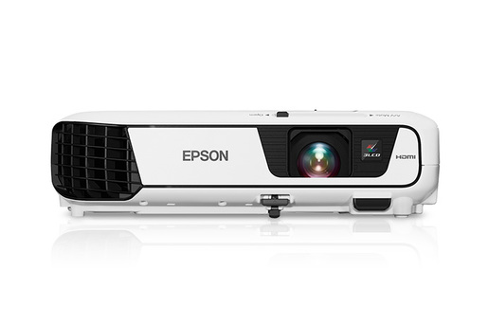

**Specifications:**

|  |  |
| --- | --- |
| **Projection System** | * Epson 3LCD * 3-chip technology |
| **Projection Method** | * Front / rear / ceiling mount |
| **Pixel Number** | * 480,000 dots (800 x 600) x 3 |
| **Aspect Ratio** | * 4:3 |
| **Native Resolution** | * 800 x 600 (SVGA) |
| **Resize** | * 1024 x 768 (XGA) * 1152 x 864 (SXGA) * 1280 x 800 (WXGA) * 1280 x 960 (SXGA2) * 1280 x 1024 (SXGA3) * 1440 x 900 (WXGA+) * 1400 x 1050 (SXGA+) |
| **Lamp Life** | * ECO mode: Up to 10000 hours * Normal mode: Up to 5000 hours |
| **Throw Ratio Range** | * 1.45 (Zoom: Wide) * 1.96 (Zoom: Tele) |
| **Size - projected distance** | * 30" – 350" (0.88 – 10.44 m) |
| **Keystone Correction** | * Automatic: Vertical: ±30 degrees * Manual: Horizontal: ±30 degrees (Easy-Slide Horizontal Image Correction) |
| **USB Plug 'n Play** | * Projects audio and video * PC and Mac compatible |
| **Contrast Ratio** | * Up to 15,000:1 |
| **Color Reproduction** | * Up to 1.07 billion colors |
| **Temperature** | * 41° to 95° F (5° to 35° C) |
| **Weight** | * 5.29 lb |
| **Security** | * Kensington-style lock provision * Password protect function |
| **Type** | * Digital zoom (Manual)/Focus (Manual) |
| **F-number** | * 1.44 |
| **Focal Length** | * 16.7 mm |
| **Zoom Ratio** | * Digital zoom 1.0 – 1.35 |
| **Display Performance** | * NTSC: 480 lines * PAL: 576 lines |
| **Interfaces** | * HDMI x 1 * Computer / Component video: D-sub 15 pin x 1 |
| **S-video** | * Mini DIN x 1 |
| **Composite video** | * RCA (Yellow) x 1 |
| **Audio in** | * RCA x 1 (White / Red) |
| **USB connector** | * Type A x 1 (PC-free USBand other, Wireless LAN) |
| **USB connector** | * Type B x 1 (USB Plug 'n Play) |
| **Speaker** | * 2 W (mono) |
| **Including feet** | * 11.7" x 9.2" x 3.2" (W x D x H) |
| **Excluding feet** | * 11.7" x 9.2" x 3.0" (W x D x H) |
| **Operating Distance** | * 19.7 ft (6 m) |
| **Operating Angle** | * Right / Left: ±30 degrees * Upper / Lower: ±15 degrees |
| **Power Supply Voltage** | * 100 – 240 V ±10%, 50/60 Hz |
| **Power Consumption** | * ECO mode: 214 W * Normal mode: 291 W |
| **Features** | * Source search selection * Power * Volume * e-zoom * A/V Mute * Freeze * Menu * page up and down, * help * auto * mouse functions |